GAMBAR 1.



http://d3q29dm4fqybkm.cloudfront.net/media/k2/items/cache/a786836489dab4f04d53706ec376ba50_XL.jpg
GAMBAR 2
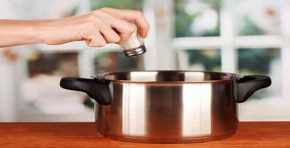
http://assets.kompas.com/data/photo/2013/02/01/1420207-garam-masak-p.jpg
GAMBAR 3
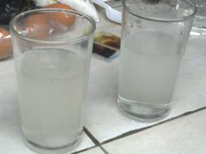
http://ditiniautami.files.wordpress.com/2011/03/air-garam.jpg
GAMBAR 4
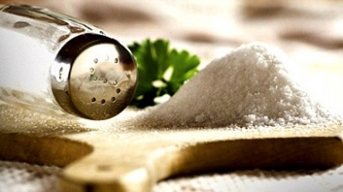
http://www.smartdetoxsynergy.com/wp-content/uploads/2012/07/Diet-Rendah-Garam-Yang-Tidak-Membosankan.jpg
GAMBAR 5
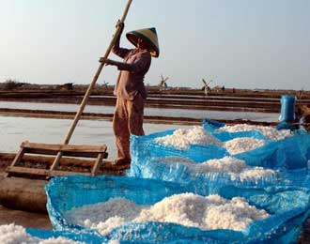
http://www.garamku.com/wp-content/uploads/2011/03/Pemerintah-Diminta-Naikkan-Harga-Pembelian-Garam.jpg
GAMBAR 6
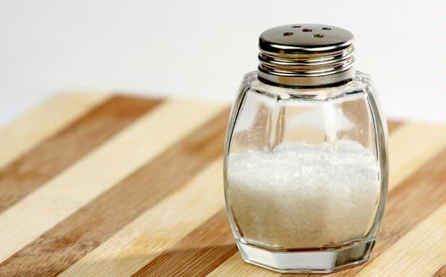
http://tourismnews.co.id/uploads/post/lepaskan-penat-dengan-mandi-garam1.jpg
GAMBAR 7
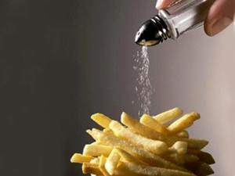
http://www.garamku.com/wp-content/uploads/2011/06/garam-yodium-2.jpg
GAMBAR 8
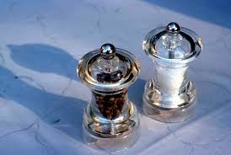
https://encrypted-tbn0.gstatic.com/images?q=tbn:ANd9GcQbZzCso1At0lXCPAvRda1csxnO1XjGEI3sUjq720zdMTgYzAv_
GAMBAR 9
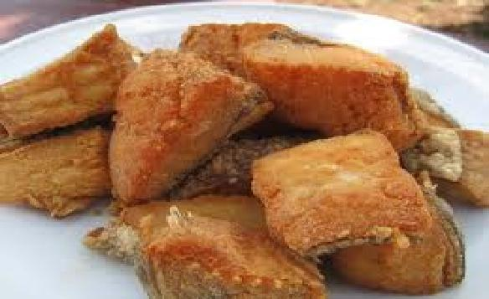
http://stat.ks.kidsklik.com/statics/files/2012/08/1345946355871274980.jpg
GAMBAR 10
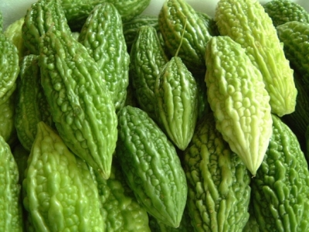
http://1.bp.blogspot.com/-fH9Xip4EBBM/Te8yGg4LN_I/AAAAAAAAAVI/EDqvSBQUJjM/s400/peria1.jpg
GAMBAR 11
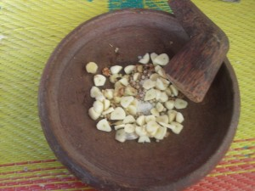
http://stat.ks.kidsklik.com/statics/files/2013/09/13782371671948468799_300x225.jpg
GAMBAR 12
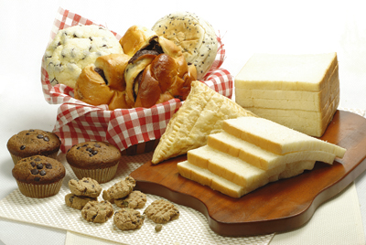
http://kulinologi.biz/gambar/roti.jpg
GAMBAR 13
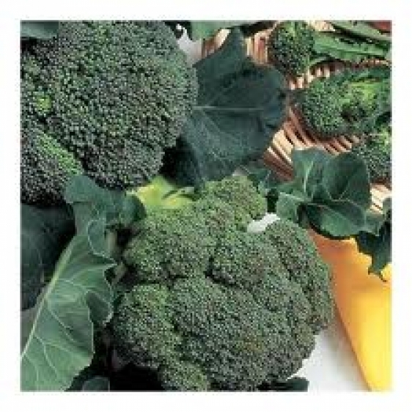http://www.recipesart.co.uk/xml_ingredients/203/big/heads%20fresh%20broccoli.jpg
GAMBAR 14
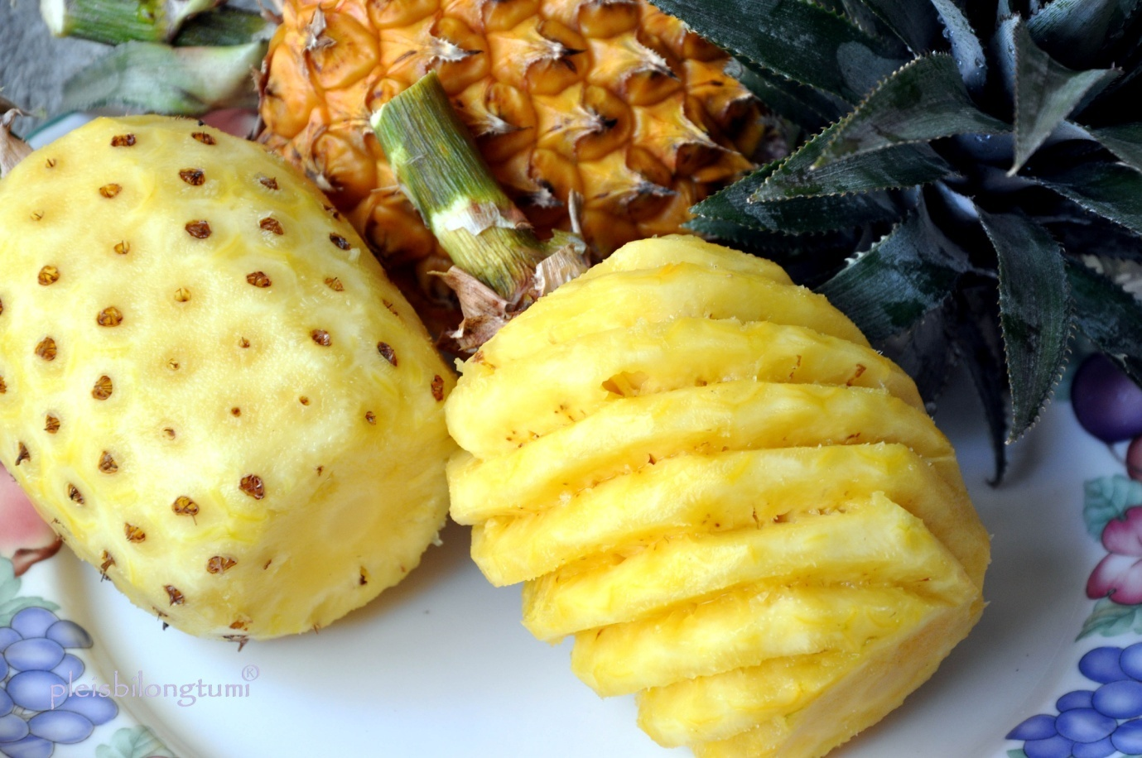
https://pleisbilongtumi.files.wordpress.com/2013/08/mengupas-nenas-bogor.jpg
GAMBAR 15
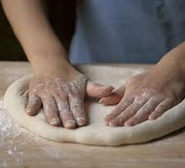
http://4.bp.blogspot.com/-qQBS8E0rmPo/T51udhUcMKI/AAAAAAAAAIc/xeNQ6X6Aa5s/s1600/ADONAN-DASAR-PIZZA-2.jpg
GAMBAR 16
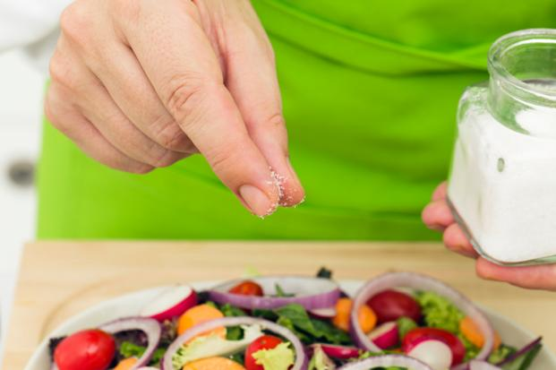

http://www.livemint.com/rf/Image-621x414/LiveMint/Period1/2012/09/05/Photos/Salt.jpg
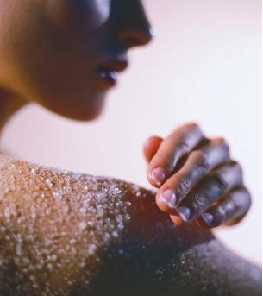
http://www.garamku.com/wp-content/uploads/2011/03/mandi-garam.jpg

http://thesensiblemom.com/wp-content/uploads/2012/07/makeupremover.jpg

http://www.visualphotos.com/photo/1x8724485/young_woman_with_salt-peeling-mask_11BSP0005RM.jpg
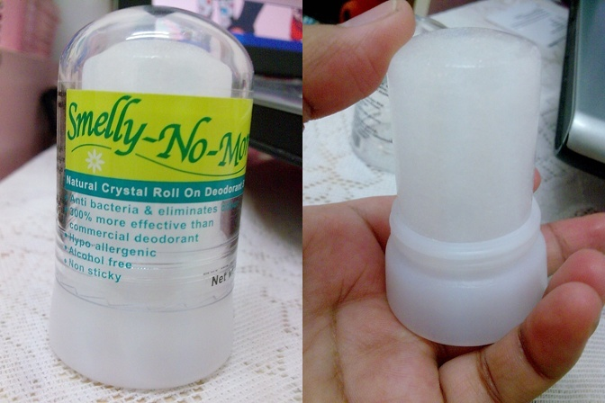
http://2.bp.blogspot.com/-Bm6404ycp5s/T5tcgt7IBTI/AAAAAAAAPu4/XA9zjPKokro/s1600/Ash022-horz.jpg
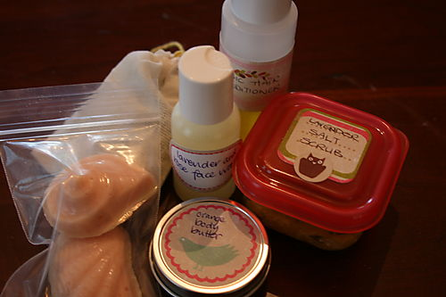
http://breadandbuttons.typepad.com/.a/6a01347fcbdbc5970c0133f543b8c9970b-pi
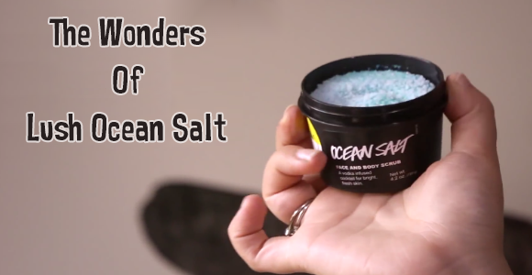
http://bestacnefacewashes.com/wp-content/uploads/2014/03/Lush-Ocean-Salt-Review-580x300.png

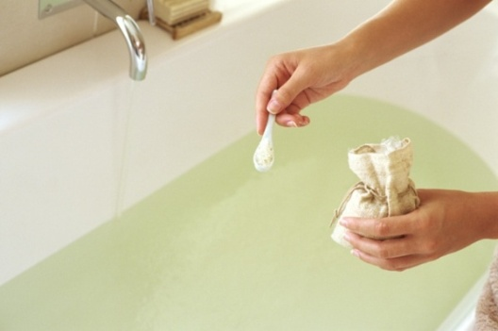
http://tourismnews.co.id/uploads/post/lepaskan-penat-dengan-mandi-garam1.jpg
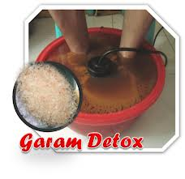
https://encrypted-tbn2.gstatic.com/images?q=tbn:ANd9GcQXmTx-SP6W8Q0SedBtwPXzKR8HPYj-7lLC866P9RRVAYv_IPZlAQ
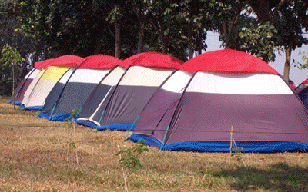
https://encrypted-tbn3.gstatic.com/images?q=tbn:ANd9GcT89OXmHZfxw3sV0VJETGTPvIuiR-obuMdg24XN5wzZcyNb9TB20A
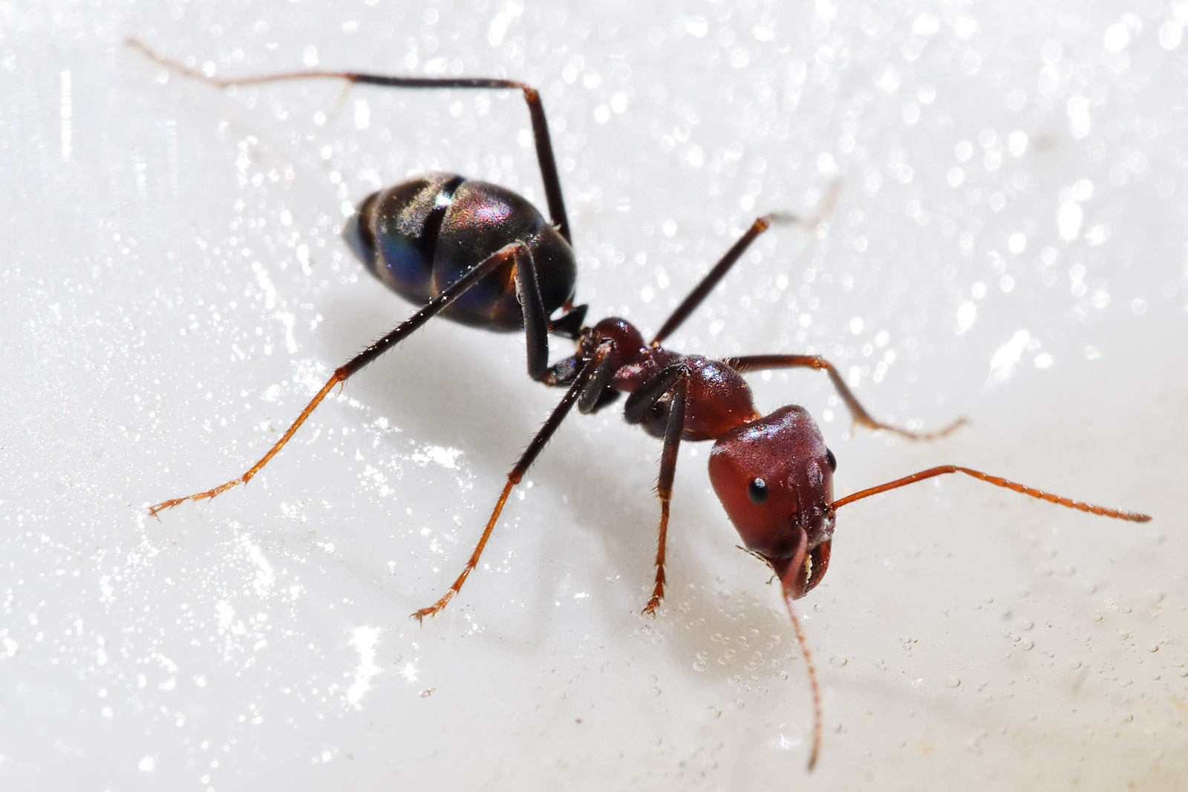
http://upload.wikimedia.org/wikipedia/commons/a/a6/Meat_eater_ant_feeding_on_honey02.jpg

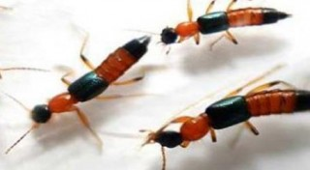
http://bangka.tribunnews.com/foto/berita/2012/4/11/Tomcat.jpg
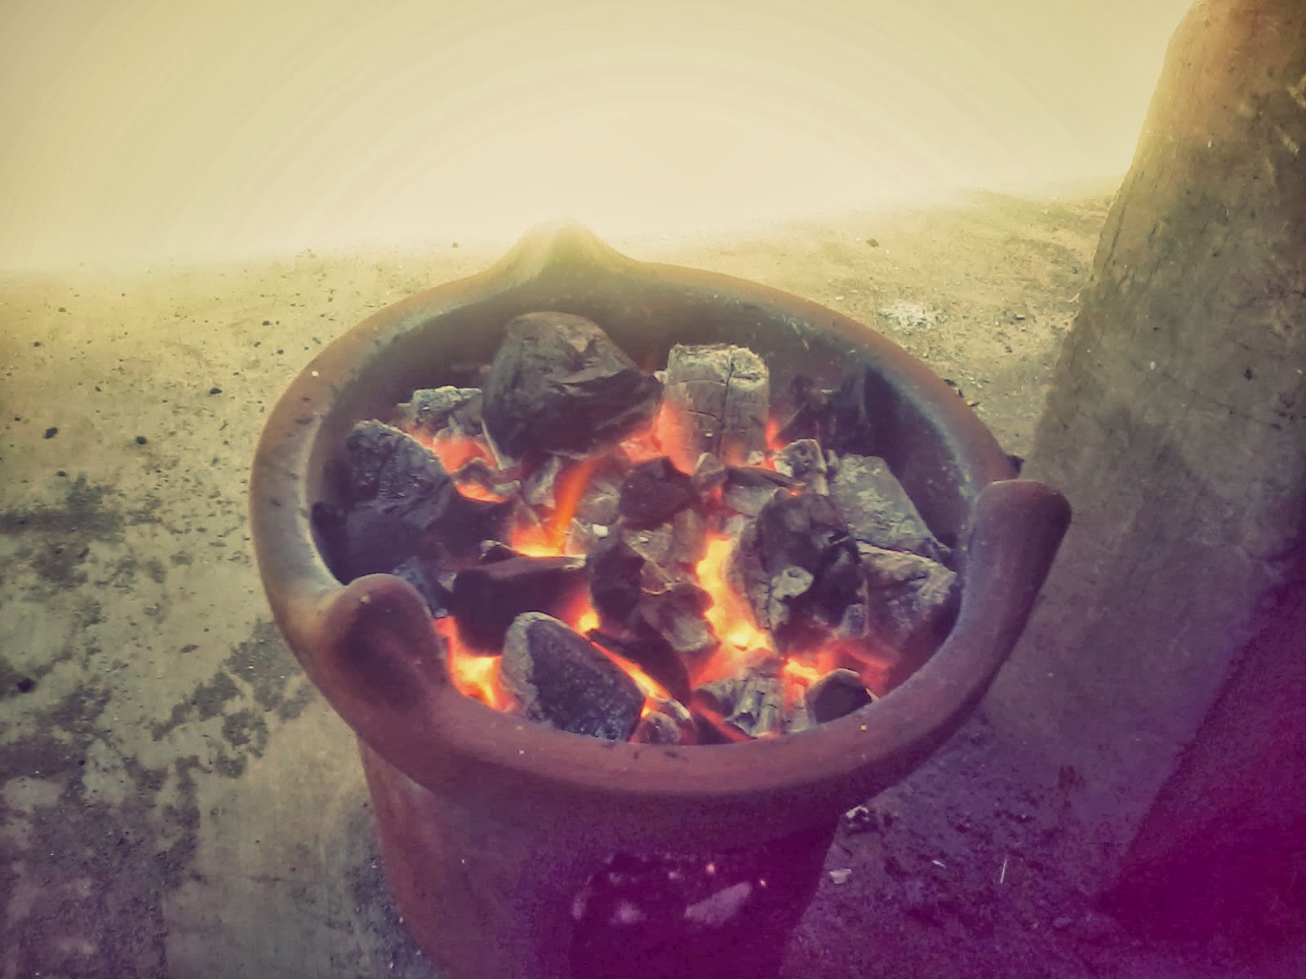
http://4.bp.blogspot.com/-WGS44ISiCf8/UnorZ6wZF3I/AAAAAAAAAGs/DtpmgS3LmdM/s1600/2013-10-17+08.40.11.jpg
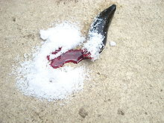
http://1.bp.blogspot.com/_04GQwKJ8H8I/TFLPyJMs5MI/AAAAAAAAABA/_FRjLCHgzTg/s400/220px-S%C3%BCl%C3%BCk_2.JPG1.JPG
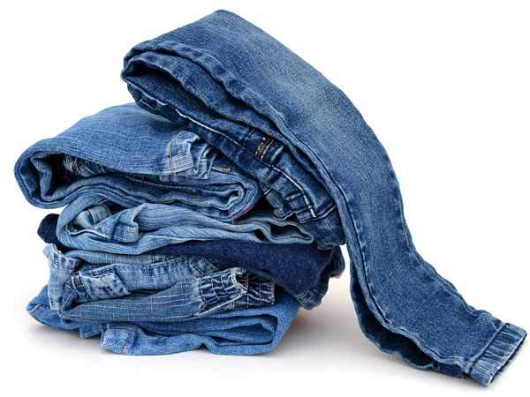
https://cauchymurtopo.files.wordpress.com/2013/04/garam1.jpg?w=620
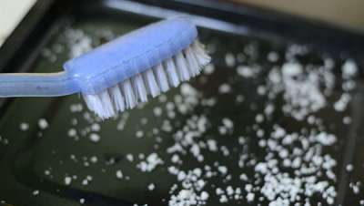
https://lh6.googleusercontent.com/-lcOyrNKm7P0/UVfZzzYnhwI/AAAAAAAAG6I/BNcWFeo_X0c/s2560/1364711883874.jpg

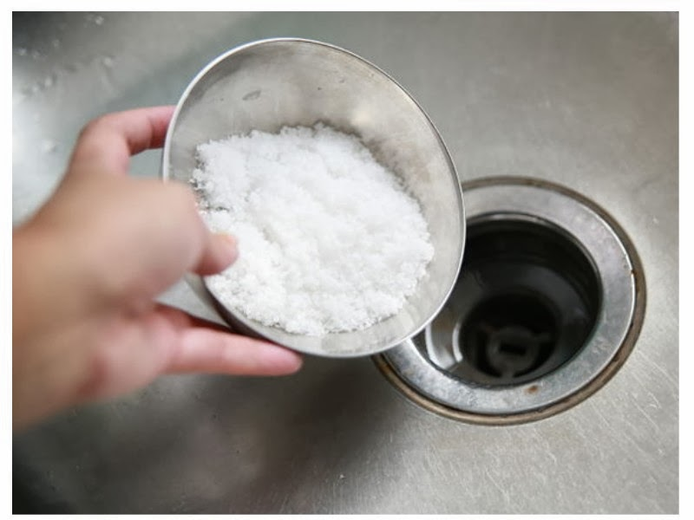
http://4.bp.blogspot.com/-f2CctRZfBUQ/UpPHT5JQHhI/AAAAAAAADo4/80bNVSM09hs/s1600/cc.jpg

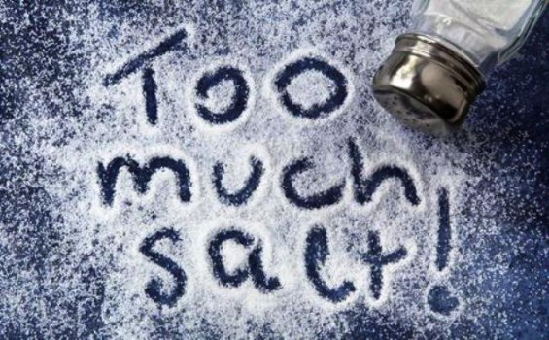
http://data.tribunnews.com/foto/bank/images/ilustrasi-garam.jpg

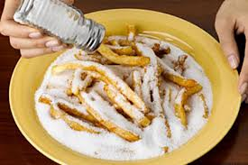
https://encrypted-tbn0.gstatic.com/images?q=tbn:ANd9GcRyfDCvc1EhH3EC0uPPLBZe6kpBcfUTFqIWQ33u4Nf900Py9Mfm

